
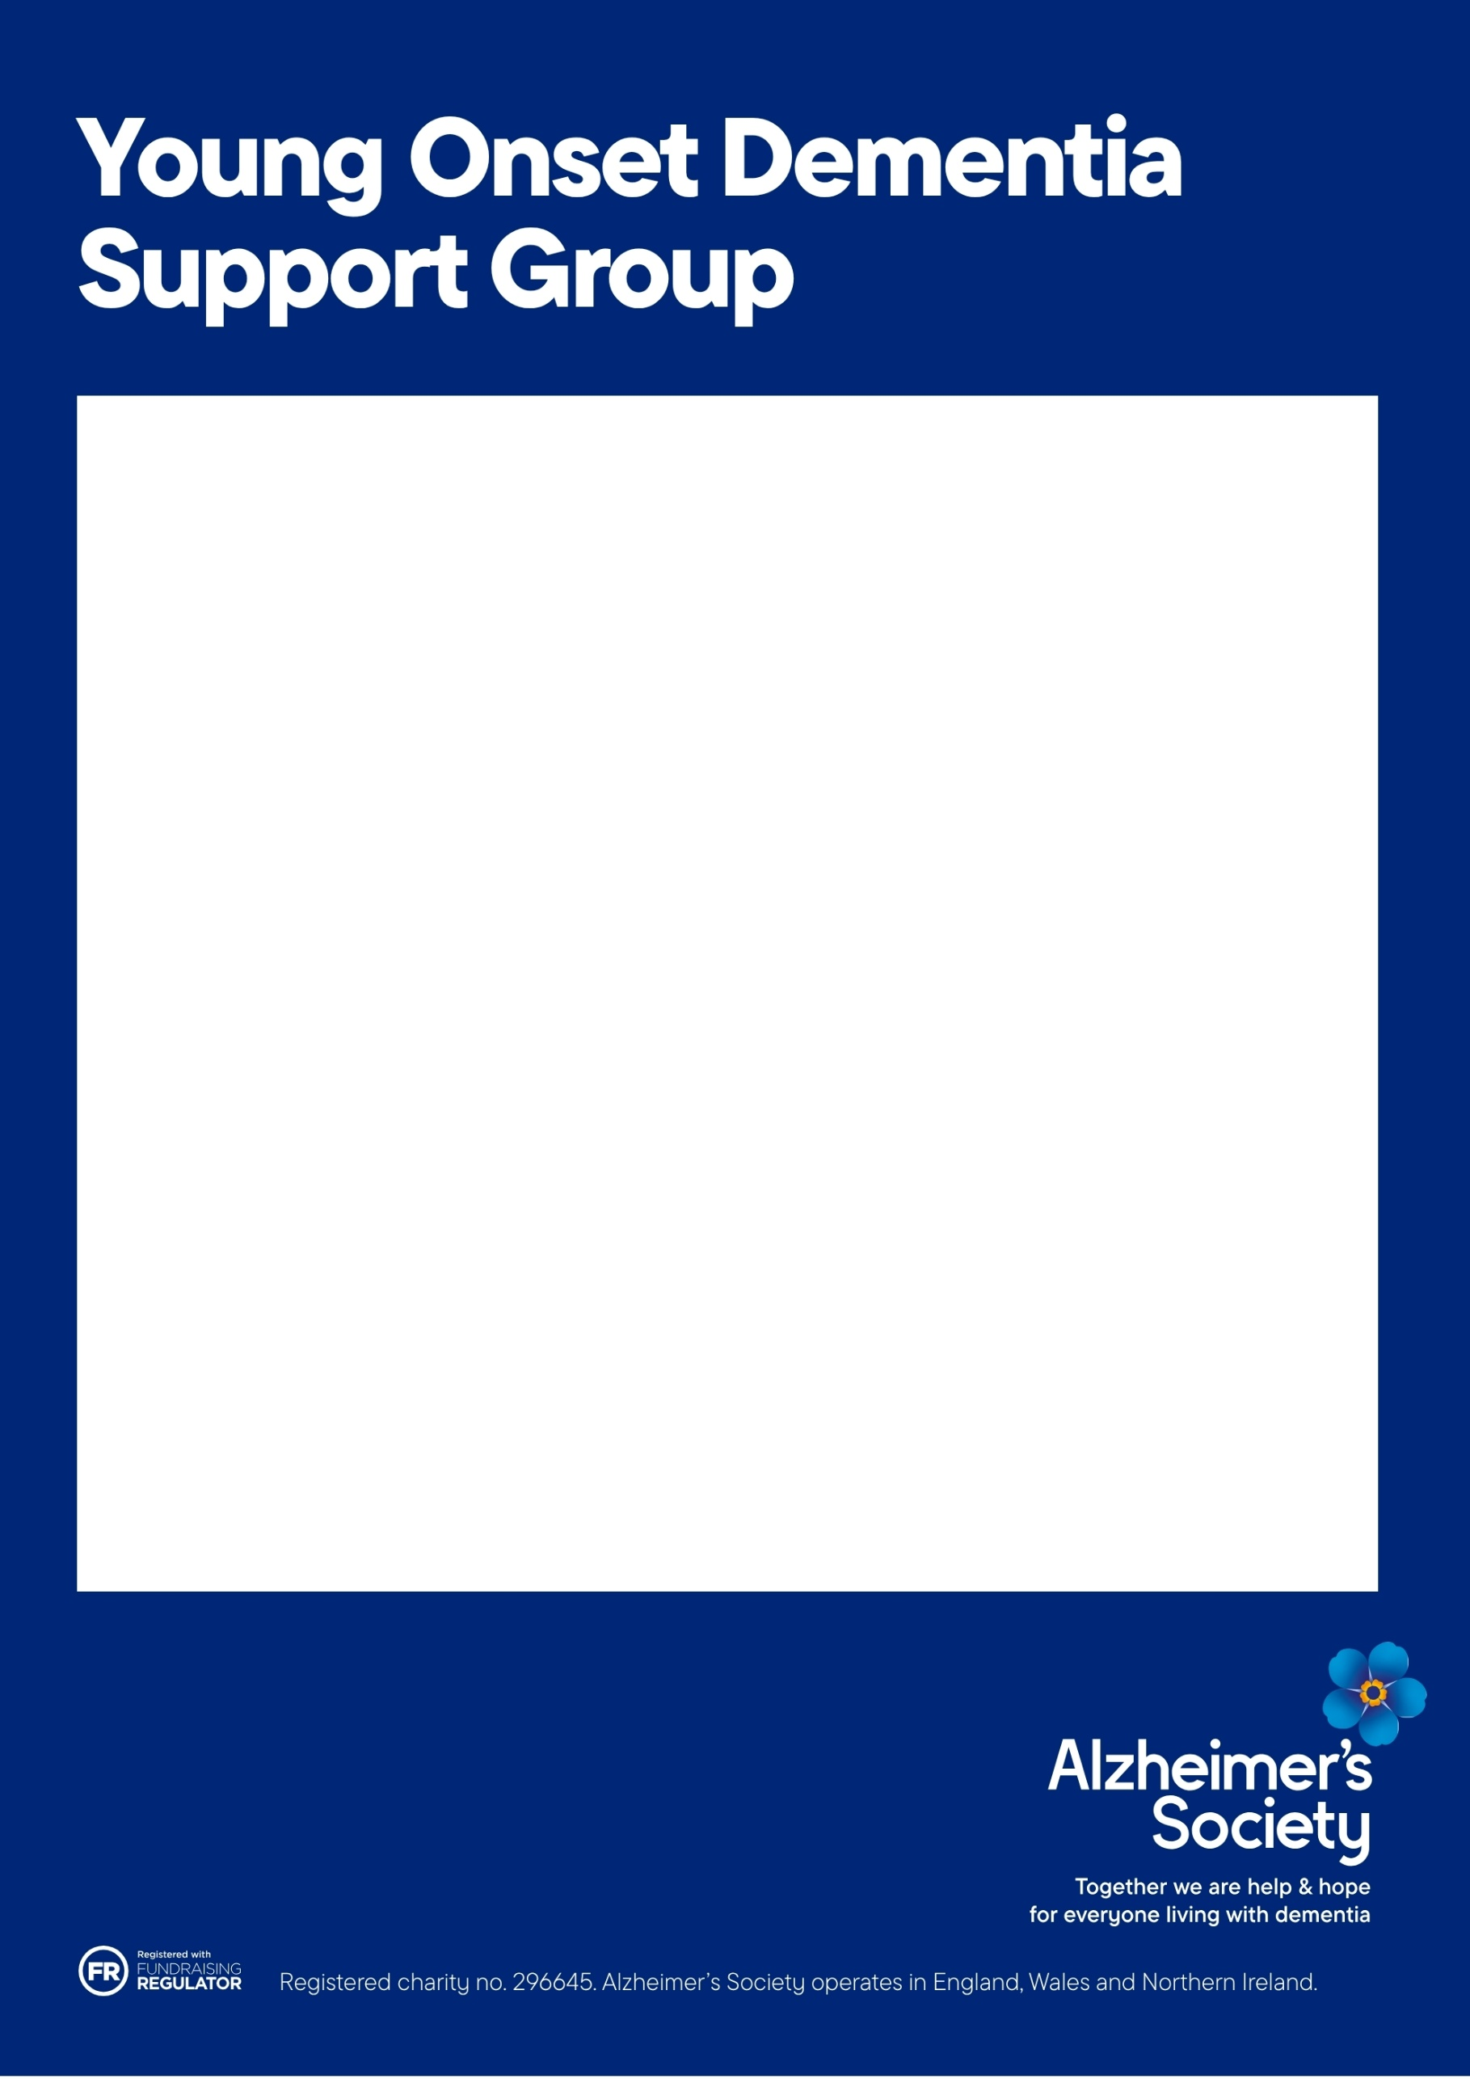
What to expect:
These informative sessions, hosted by the
Lead Dementia Adviser for Young Onset
Dementia, are an opportunity to meet and talk
with other people living with or caring for people living with Young Onset Dementia, to share ideas and experiences.
"Being part of this group, allows us to share and gain knowledge in a kind and supportive environment, from others who are in a similar situation"

Derbyshire's Young Onset Dementia Forum
Our online Young Onset Dementia forum is on the first Tuesday of the month, with the sessions starting at 6pm and ending around 7.30pm via Zoom.



Scan to access the Derbyshire Dementia Information and Advice Service Self-Referral Enquiry Form

Interested in joining? We’d love to hear from you.
If you’d like to know more about this group, or would like to join us, please contact us:
01332 208845 (Monday to Friday, 9am – 5pm)
or email derbyshire@alzheimers.org.uk

